RM Research - Compass - Guided Authentication Without Using CTI
Process
Related Documents

Description: This document outlines Guided Authentication steps and functionality for Compass when a member’s account is accessed without a caller on the line, with the intent of making changes and/or research.

Process
Prior to accessing a member’s account, the business purpose for accessing the account must be indicated by one of the following:

- Interaction Case: Performing activity or action on a member’s account. Examples: Adding an override, changing the address, etc. when a member is not on the line.

- Research Case: Performing activity that does NOT involve member interaction or servicing the member directly. Research Cases are typically View only for quality review follow up issues that do not require changes to the member.

Authentication requirements are dynamic and embedded into the CRM system. Agents must proceed through the Guided Authentication process, regardless of whether there is a caller on the line or not when Interaction Case is selected.
- The agent is presented with suggested scripting and guided through the authentication process. Agents must follow the steps provided on the screen.
- As the agent proceeds through the call flow script, the system presents the next set of steps and/or questions, prompting the agent to gather and enter information into the system.
- Click the Next button to move through the Guided Authentication process.
- Information entered during the Guided Authentication process will be auto populated in the Case Notes.

Note: Calls that come through the CTI will automatically open as an Interaction Case.

Follow the steps below:
Step | Action
1 | Search for the member in Compass.  Result: Member’s account is located, and the Access Member Information window displays.
2 | Select Interaction Case from the dropdown.  Result: The Guided Authentication flow is launched.
3 | Enter the agent’s name into the Caller Name field, then click Next.  Note: An agent can select the Close Case button to return to the Search by Member.
2 | Choose Other from the Who is Calling dropdown.  Notes:  - Defaults to Retail Pharmacy for PHD.  - Depending on the relationship to member selected in the Who is calling field, different procedural verification fields will appear.  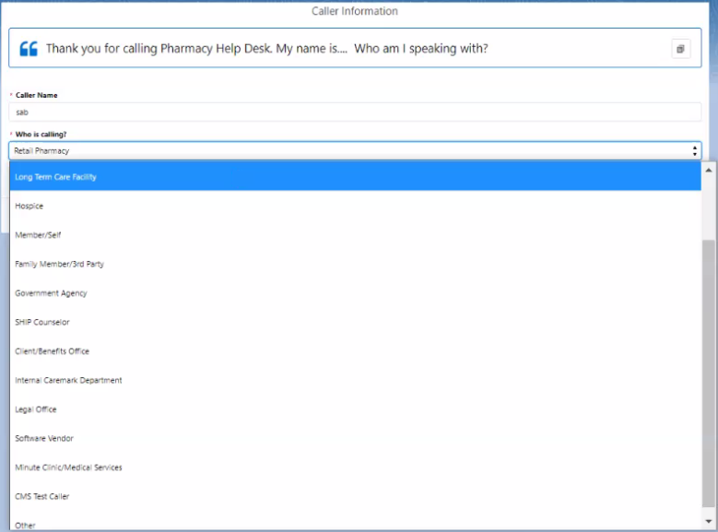  Result: Other Relationship field displays.  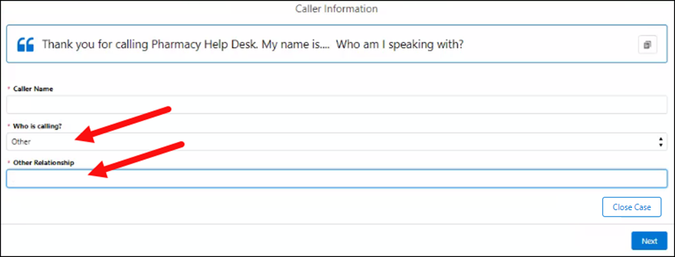
3 | Enter your job title in the Other Relationship field, then click Next to proceed.  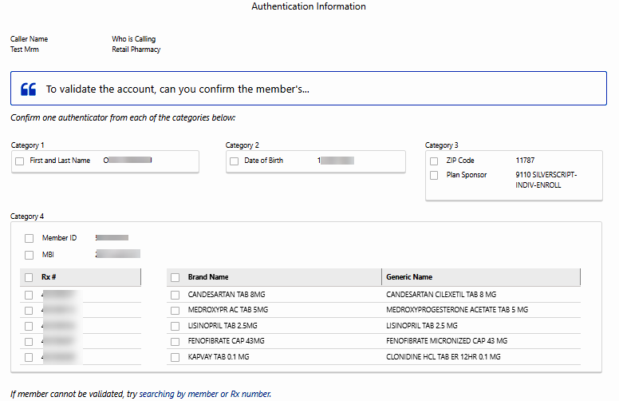  Result: Authentication tokens display.
4 | Validate the account by checking the boxes for the following tokens (viewable in the Service Resolution screen):  - Name  - DOB  - Member ID  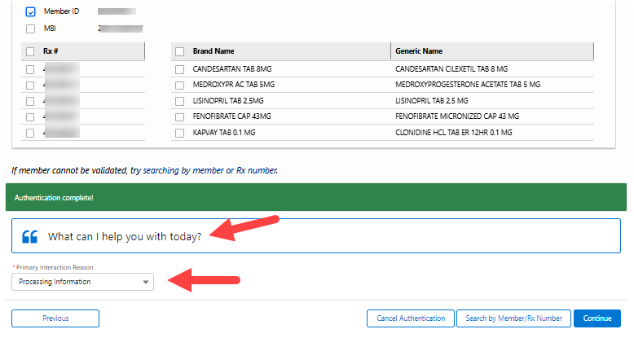  Result: A green Authentication complete! confirmation banner displays.
5 | Choose Support Task from the Primary Interaction Reason dropdown.  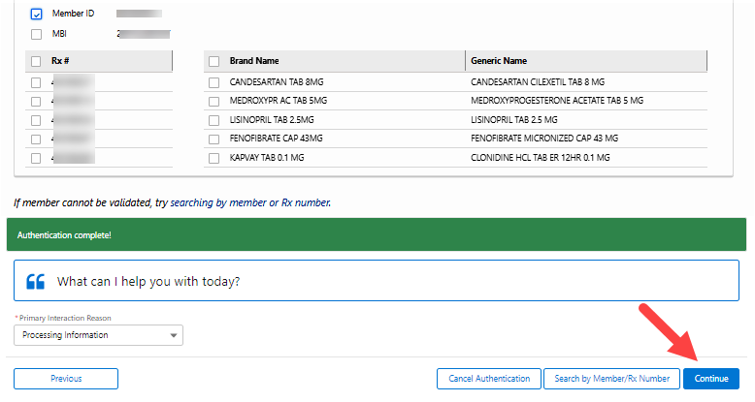  Result: Continue button illuminates.
6 | Click the Continue button to proceed to the Member Snapshot screen.  Results:  - The Authentication tab closes automatically, and a confirmation banner displays.  - Member Snapshot screen displays, and a new Case tab is created.  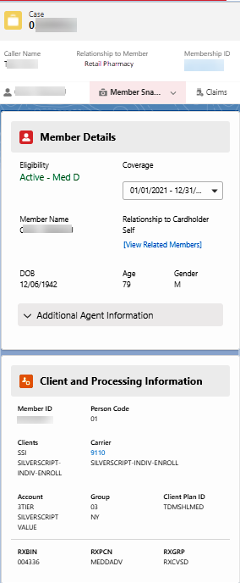

Top of the Document

Related Documents
Parent Document: CALL-0113 Customer Care Resolution Manager Research

Top of the Document

Not To Be Reproduced Or Disclosed to Others Without Prior Written Approval
ELECTRONIC DATA = OFFICIAL VERSION / PAPER COPY = INFORMATIONAL ONLY

